THEHARVESTER TOOL – COMPREHENSIVE TECHNICAL DOCUMENTATION
An OSINT-Based Information Gathering Tool for Ethical Hacking & Penetration Testing

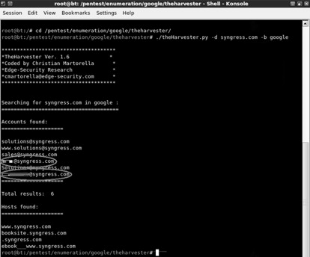
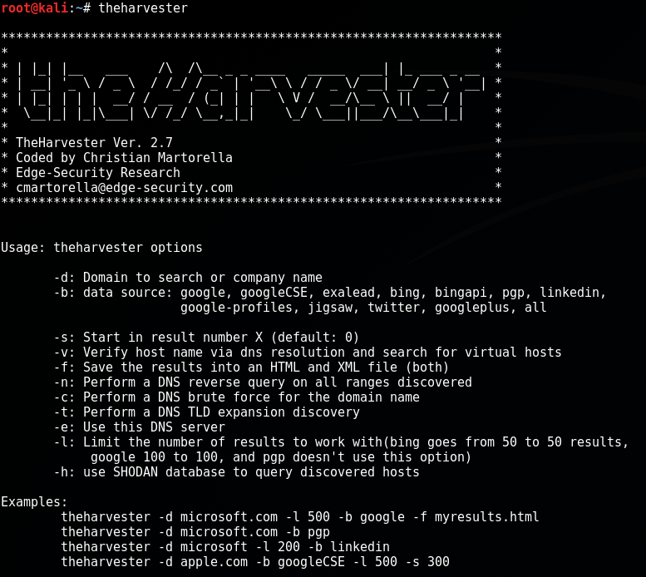

ABSTRACT
Information gathering is the foundation of every successful cyber attack and penetration testing engagement. Before exploiting vulnerabilities, attackers first collect intelligence about an organization’s digital footprint, employees, domains, and infrastructure. This document presents a comprehensive technical study of theHarvester, an open-source Open-Source Intelligence (OSINT) tool used to gather emails, subdomains, IP addresses, and employee information from public sources. The report explains the theoretical background, internal working methodology, command usage, practical case study, advantages, limitations, and defensive considerations of theHarvester. The objective of this documentation is to provide an academic and practical understanding of theHarvester suitable for cybersecurity coursework and professional security assessments.

1. INTRODUCTION
In modern cyber security attacks, direct exploitation is rarely the first step. Instead, attackers begin by understanding their target—who works there, what infrastructure is used, and how systems are exposed to the internet. Much of this information is publicly available and can be collected without interacting directly with internal systems.
This type of intelligence gathering is known as Open-Source Intelligence (OSINT). OSINT allows attackers and ethical hackers to collect valuable data from search engines, public databases, social platforms, and online services.
theHarvester is a widely used OSINT tool designed to automate this process. It focuses on collecting emails, subdomains, IP addresses, and related metadata associated with a target organization. This document explores theHarvester in depth and highlights its importance in reconnaissance.

2. OBJECTIVE OF THE STUDY
The objectives of this documentation are:
- To understand OSINT-based information gathering
- To study the working mechanism of theHarvester
- To analyze theHarvester commands and options
- To demonstrate real-world usage through a case study
- To evaluate strengths, limitations, and security implications
- To provide exam-ready and submission-ready material

3. BACKGROUND: OSINT IN CYBER SECURITY
Open-Source Intelligence refers to the collection of information from publicly accessible sources. In cyber security, OSINT is primarily used during the Reconnaissance (Information Gathering) phase of penetration testing.
OSINT can reveal:
- Employee email addresses
- Organizational naming conventions
- Publicly exposed subdomains
- Cloud services and IP ranges
- Technology stacks and providers
Because OSINT does not involve direct exploitation, it is often difficult to detect and block.
theHarvester specializes in automating OSINT collection from multiple public data sources.

4. OVERVIEW OF THEHARVESTER TOOL
theHarvester is an open-source OSINT tool written in Python and widely included in Kali Linux. It collects information related to a target domain or organization by querying multiple public sources such as search engines, threat intelligence platforms, and certificate transparency logs.
Unlike DNS enumeration tools that focus only on domains, theHarvester also gathers email addresses and employee-related information, making it especially useful for social engineering and phishing assessments.
theHarvester does not exploit vulnerabilities. Its primary function is intelligence gathering.

5. ARCHITECTURE AND WORKING MECHANISM

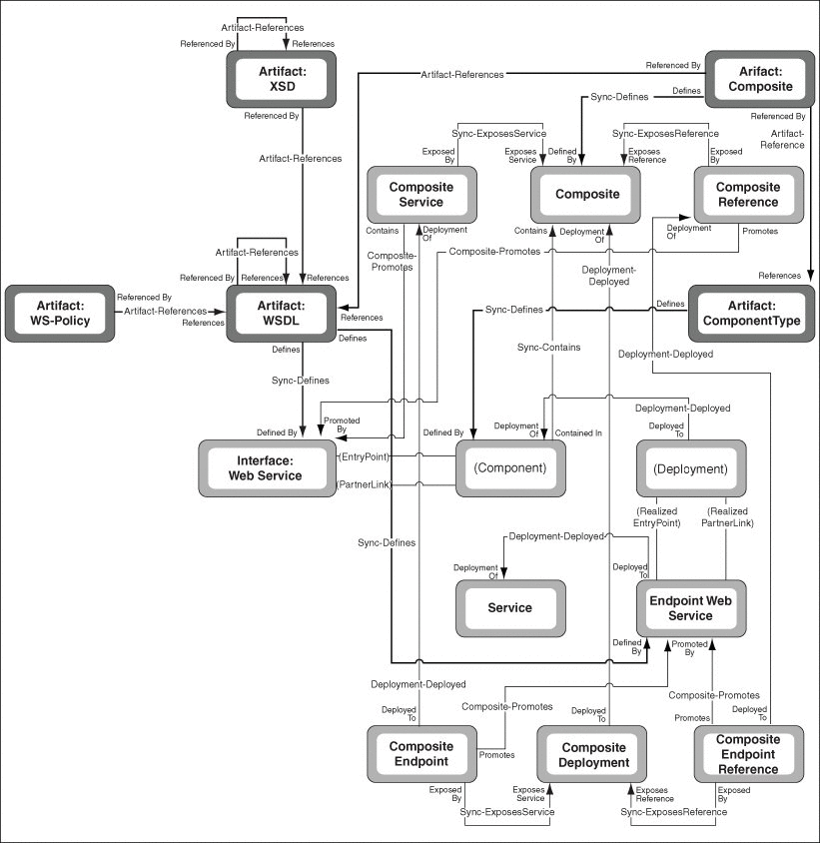
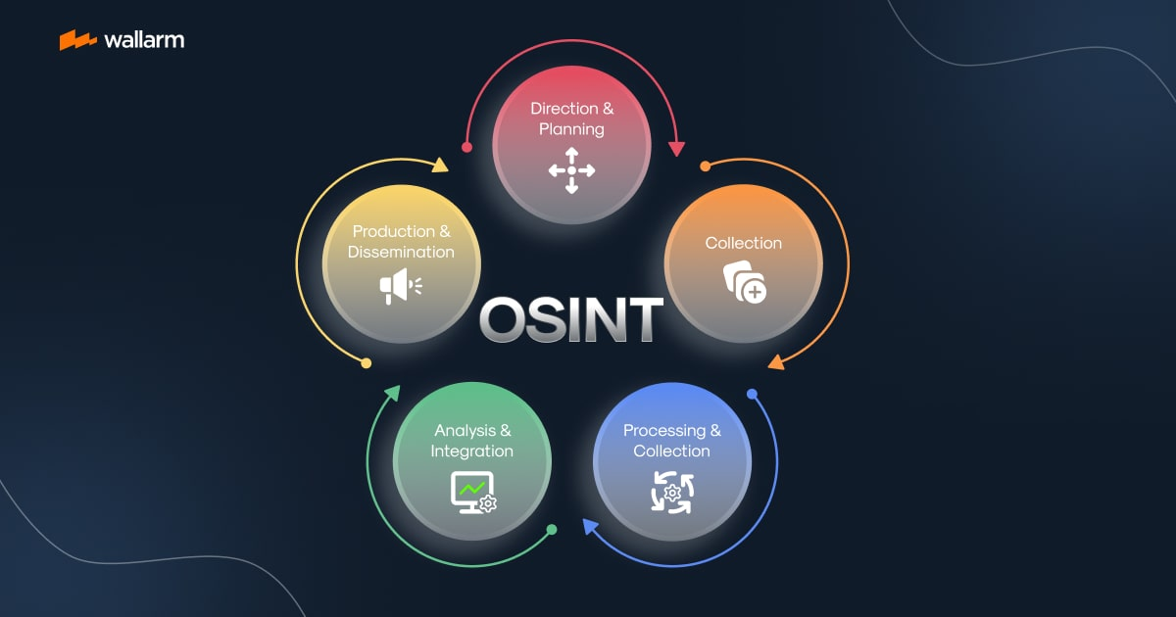
theHarvester operates through the following stages:
- Target Definition
The user specifies a domain name or organization.
- Data Source Querying
theHarvester queries multiple public data sources such as search engines and APIs.
- Data Extraction
Relevant information such as emails, subdomains, and IP addresses is extracted.
- Result Aggregation
Data from all sources is combined and de-duplicated.
- Output Generation
Results are displayed or saved for further analysis.
This workflow enables efficient intelligence gathering with minimal effort.

6. INSTALLATION AND ENVIRONMENT
theHarvester is pre-installed in Kali Linux and can also be installed manually using GitHub.
To verify installation:
theHarvester --help
theHarvester requires internet connectivity to query OSINT sources.

7. COMMAND USAGE AND ANALYSIS
7.1 Basic Information Gathering
theHarvester -d example.com -b google
Collects emails and subdomains using Google as the data source.

7.2 Using Multiple Data Sources
theHarvester -d example.com -b bing,duckduckgo
Queries multiple search engines for broader coverage.

7.3 Limiting Results
theHarvester -d example.com -b google -l 100
Restricts the number of results to avoid excessive output.

7.4 Saving Output to File
theHarvester -d example.com -b all -f harvester_results
Saves results in structured formats for reporting.

7.5 Passive DNS Enumeration
theHarvester -d example.com -b certspotter
Uses certificate transparency logs to discover subdomains.

8. PRACTICAL CASE STUDY
Scenario
A penetration test is conducted on a fictional organization named example-corp.com.
Execution
theHarvester -d example-corp.com -b all
Observations
- Discovered employee email addresses
- Identified development and cloud subdomains
- Revealed third-party hosting providers
Impact Analysis
The collected data enabled targeted phishing simulations and prioritized further technical testing.

9. ADVANTAGES OF THEHARVESTER
- Passive and stealthy reconnaissance
- Collects both technical and human-related data
- Supports multiple OSINT data sources
- Easy to use and widely supported
- Valuable for social engineering assessments

10. LIMITATIONS OF THEHARVESTER
- Dependent on external data source availability
- Accuracy depends on public data quality
- Limited depth compared to Amass
- Requires internet connectivity

11. THEHARVESTER VS OTHER RECON TOOLS
Tool | Focus Area | Strength
theHarvester | Emails & OSINT | Social engineering
Sublist3r | OSINT subdomains | Stealth
Amass | Attack surface mapping | Depth & scale
DNSENUM | DNS enumeration | Academic & learning
theHarvester is best suited for human-centric reconnaissance.

12. SECURITY AND DEFENSIVE CONSIDERATIONS
Organizations can reduce OSINT exposure by:
- Limiting public email address disclosure
- Using email obfuscation techniques
- Monitoring search engine indexing
- Training employees against phishing attacks

13. LEGAL AND ETHICAL CONSIDERATIONS
theHarvester must only be used with explicit authorization. While OSINT relies on public data, misuse can lead to privacy and legal violations.

14. CONCLUSION
theHarvester highlights how much sensitive organizational information is publicly accessible on the internet. Its ability to gather emails and infrastructure details makes it a powerful reconnaissance tool for ethical hackers. Understanding theHarvester equips cybersecurity students and professionals with critical skills for both offensive security and defensive awareness.

15. REFERENCES
- Kali Linux Official Documentation
- OWASP OSINT Guidelines
- OSINT Framework
- Certificate Transparency Documentation

